-----: Django mail() Servces :----
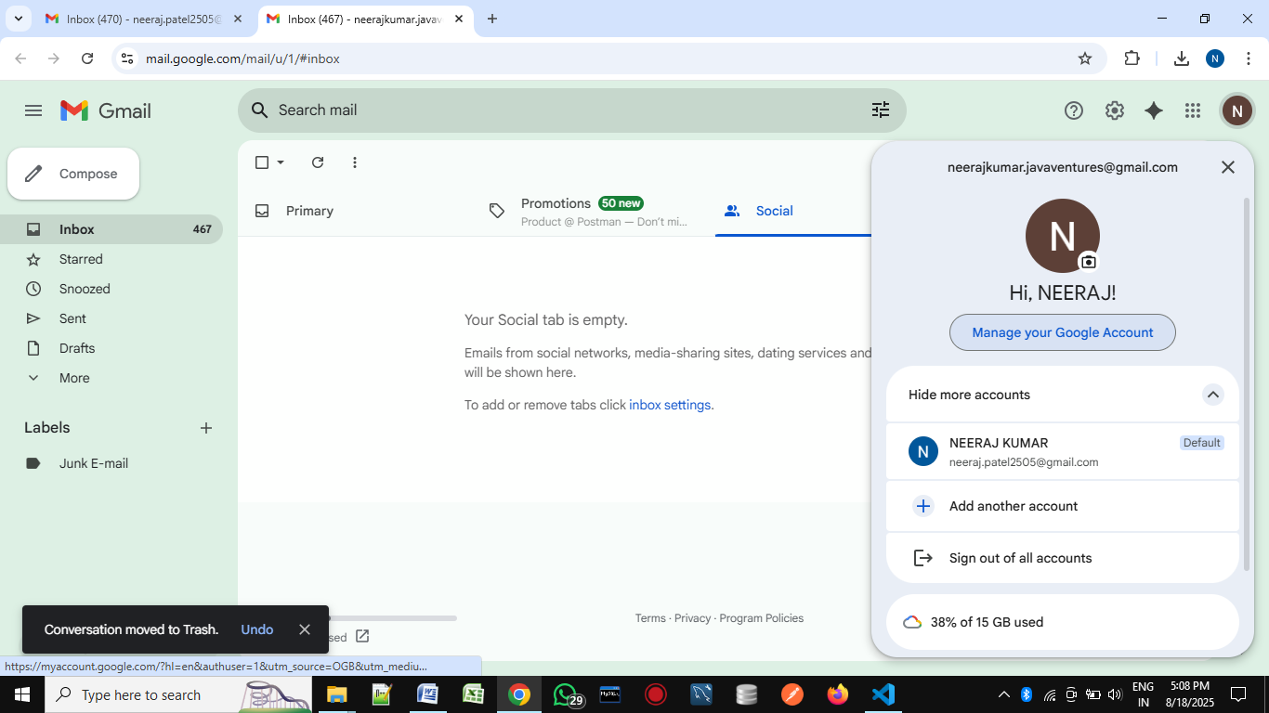

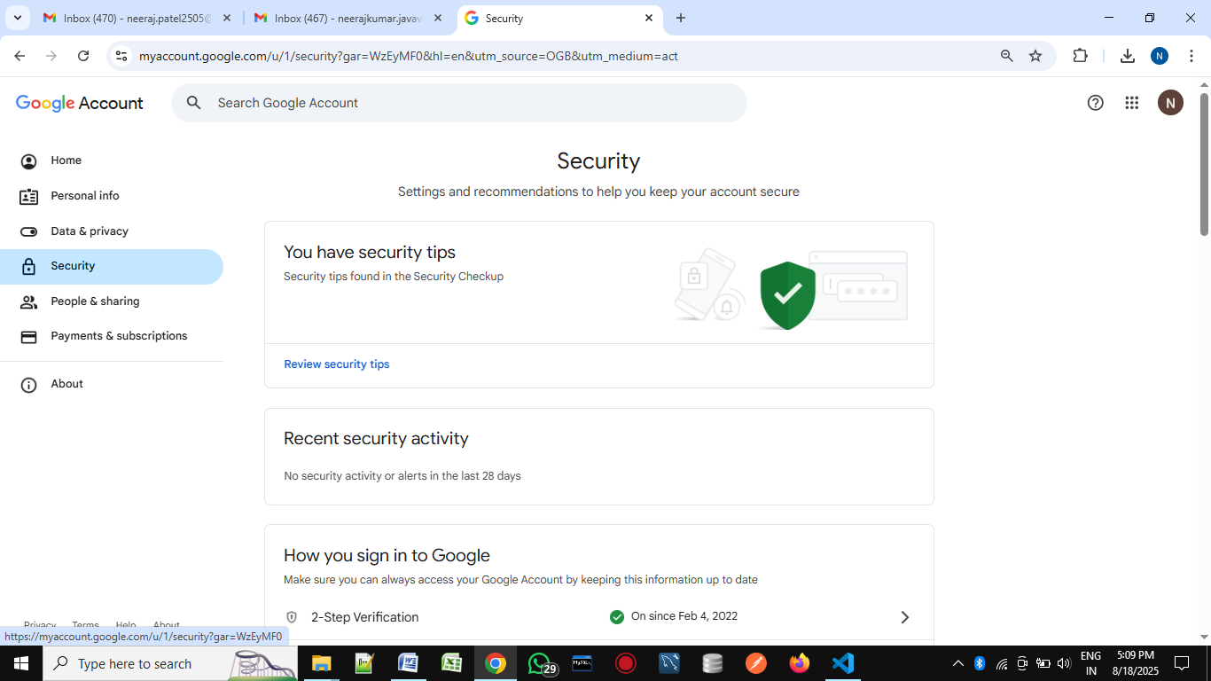
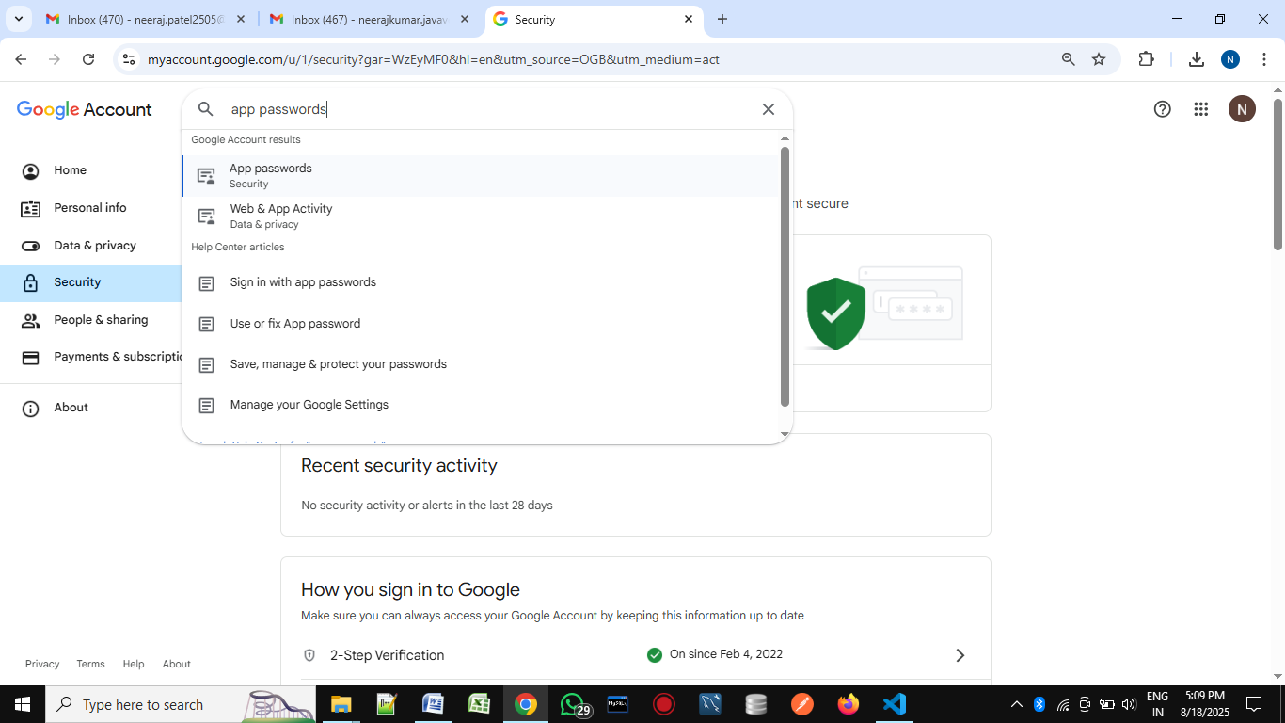

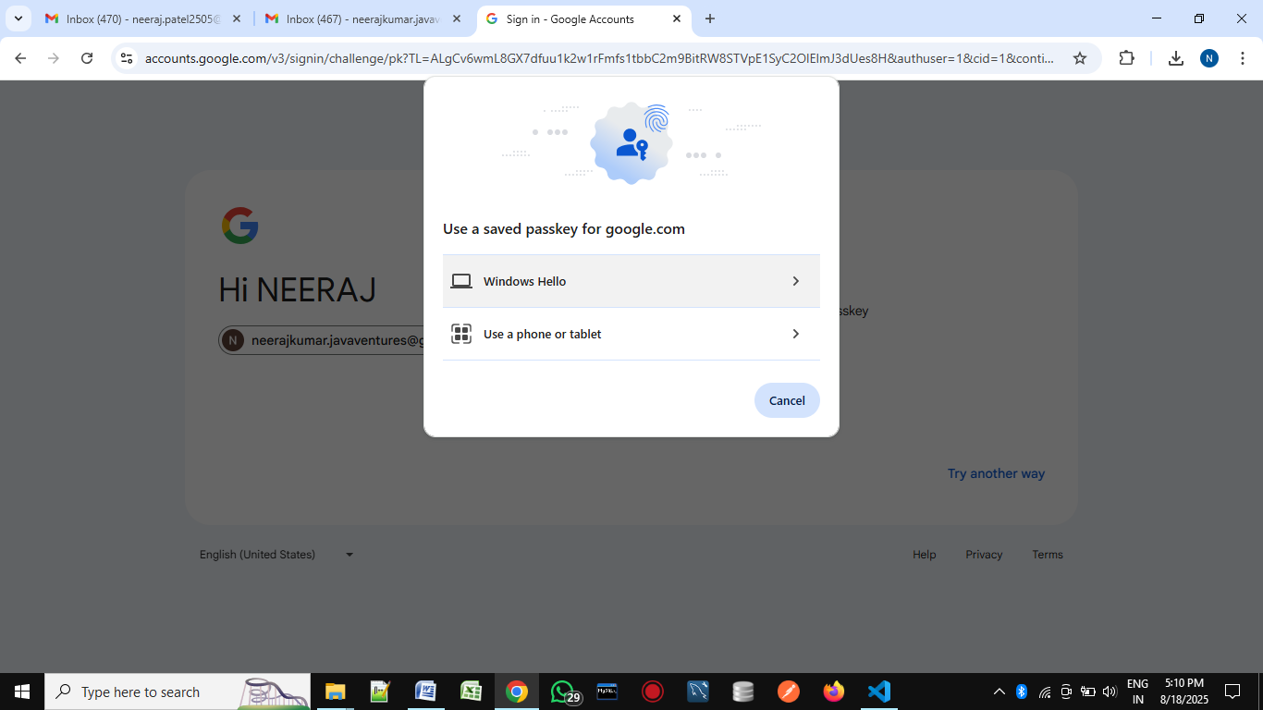
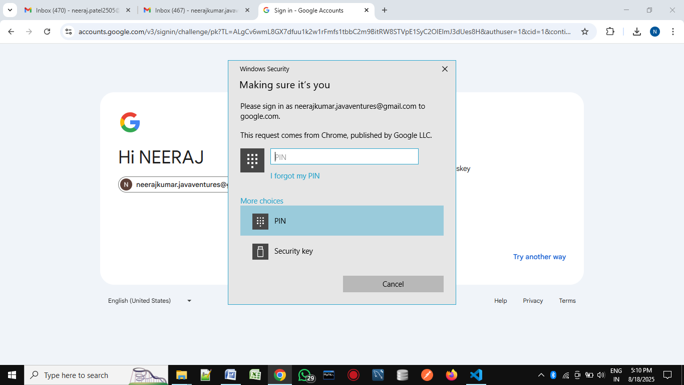

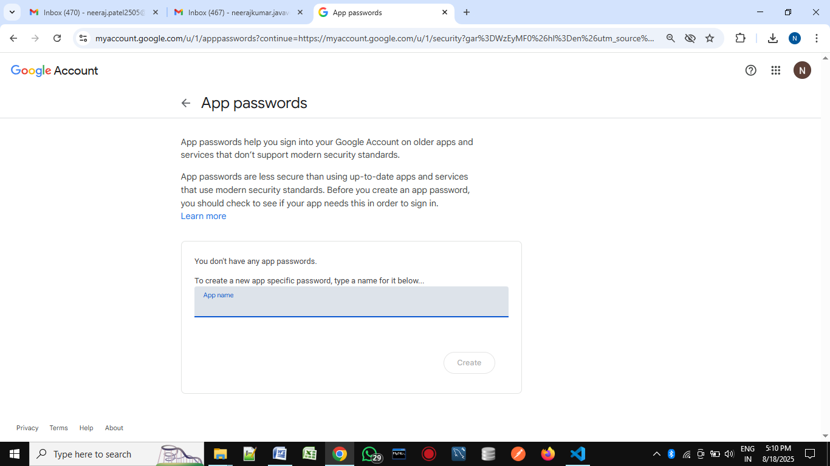
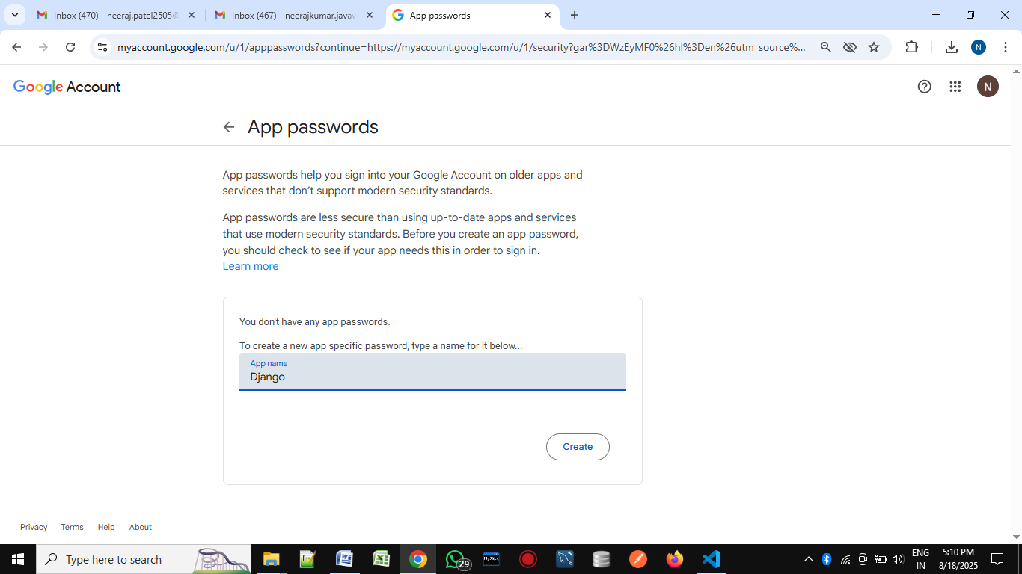

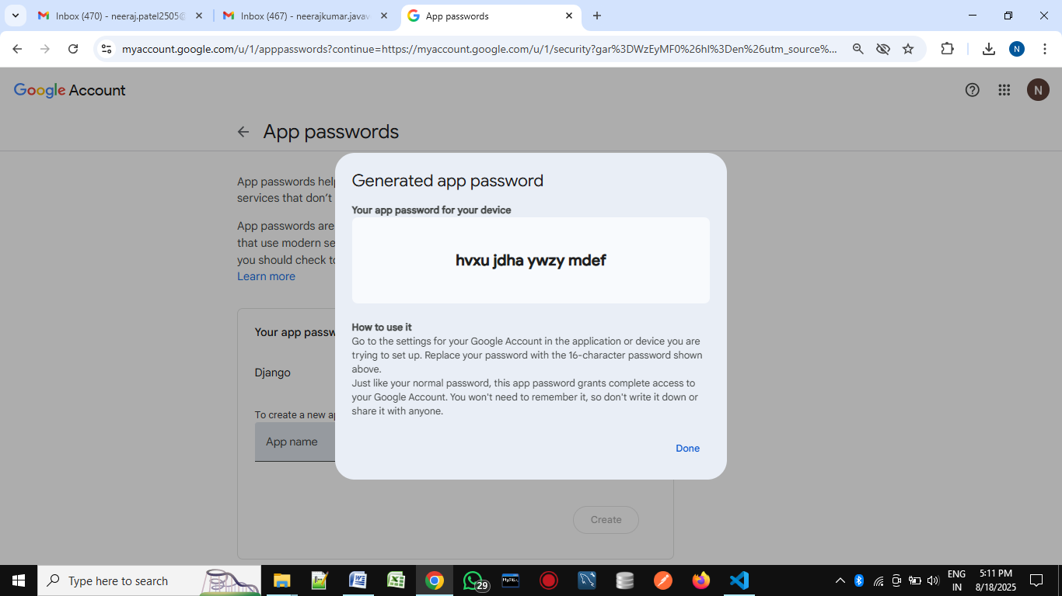

Project/settings.py:-----

EMAIL_BACKEND = 'django.core.mail.backends.smtp.EmailBackend'
EMAIL_HOST = "smtp.gmail.com"
EMAIL_PORT = 587
EMAIL_HOST_USER="neeraj.patel2505@gmail.com"
EMAIL_HOST_PASSWORD="gzwbdslifvkbpdzu" # "qpipirzgvdiczkse"
EMAIL_USE_TLS=True

# generate less secure password in from your gmail account
# 1. login your gmail account
# 2. click your profile
# 3. click on manage your google account
# 4. click on security options
# 5. click on 2-step varification will be on
# 6. search app passwords on search bar.
# 7. generate new password for less secure apps
# 8. write this 16-digit password hear below

